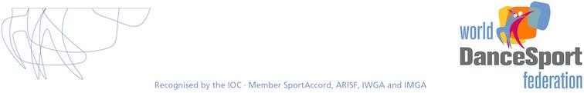

Appendix WDSF Dress Regulations

These Regulations are part of the WDSF Competition Rules by reference in Rule E.10.

Authority and Applicability

These Dress Regulations apply to all competitions granted by WDSF and according to the decision of the WDSF Annual General Meeting, form part of the competition rules of all WDSF Member bodies provided always that WDSF Member bodies may impose additional dress restrictions at their own discretion for national non-WDSF-named events.

The WDSF Presidium retains the authority to impose specific additional or general Dress restrictions or otherwise amend or allow exemptions, for specific events.

GENERAL

1. Female athletes may not wear shorts, culottes or leotards alone but they can be worn with a skirt. Female Athletes must wear a skirt, dress or long trousers. Skirts and dresses must create Characteristic shape for each discipline (ST and LA) (shape area). In Standard Dress the lady’s or girl’s dress must have a long skirt which at minimum covers both her knees; if the skirt is split it must not be split higher than the knee. In Latin Dress the lady’s or girl’s dress must have a skirt made of fabric, fringe, feathers , beads or any other suitable material, and can be split or open on the sides, provided always that the skirt must completely cover the panties in front and in the back when standing still.

2. | A n | a t h l e t e ’ s | c o s t u m e must cover the intimate parts of that athlete’s body (“the intimacy area”).
3. | A | l a d y ’ s o r | g i r l ’ s d ress and makeup must be appropriate for her age and the level of competition
which is being danced.

- In order to present a more modern and up-to-date image of DanceSport, a suit jacket with collared shirt and tie, or a vest with collared shirt and tie is recommended for the Junior II, Youth, Adult and Senior age groups.

- Athletes may not use religious symbols as decoration or decoration jewellery but may use religious symbols as part of their personal jewellery.

- The Chairman has full authority to require any athlete to remove an item of jewellery or dress at any time if in the Chairman’s opinion that the item of jewellery or dress poses a potential danger to that athlete or to other competitors.

STATUS: 2014 WDSF AGM, BUCHAREST, ROMANIA, JUNE 15, 2014

7. A n a t h l e t e m a y c o m p e t e w e a r i n g a c o s t u m e w h i c h i s r e q u i r e d i n a l o w e r c a t e g o r y .

8. The Chairman may suspend from competition any athlete who fails to comply with these guidelines or fails to comply with the Chairman’s directions at a competition, and may direct the Scrutineer not to record the marks given to such an athlete in any competition in which the athlete fails so to comply.

Good Taste Rule

Any use of material or colour or construction or other contrivance that gives the appearance of non compliance with these dress rules, even though there is no breach of the literal wording of these rules, will be a breach of these rules if so determined by the Chairman of Adjudicators.

SANCTIONS

If a couple is not dressed in accordance with this Dress Regulation and receives a warning from the Chairman of adjudicators, they must comply with the regulation or face disqualification

IMMEDIATELY BY THE CHAIRMAN of the WDSF Sports Director, if present. The Presidium can impose additional sanctions including suspension from competitions for repeat offenders.

DEFINITIONS OF TERMS

No restriction (NR) – there are no restrictions in this matter

Not allowed (NA), Only allowed (OA),

Intimacy area (IA) – body zones, which must be covered by non transparent materials or transparent materials lined with non transparent materials. If skin colour is used in an athlete’s costume, it must be SwD.

Rules

For the Female partner:

- tangas are NA.

- skin colours panties are NA.

- Breasts must be covered

- the distance between bra cups must be less than 5 cm.

Shape area (SA) – minimum area which must be covered. Transparent materials are allowed in these areas, any colour is allowed.

Basic material – creates shape of the dress

- with light effects (metallic, glitter, sequins, …)

- without light effects

STATUS: 2014 WDSF AGM, BUCHAREST, ROMANIA, JUNE 15, 2014

Decoration – anything fixed on the basic material, hair, skin:

- with light effects (rhinestones, sequins, beads, pearls, …)

- without light effects (feathers, flowers, bows, fringe, lace applications, ribbons, …)

Tie clips, studs, cufflinks, buckles are not defined as decorations.

Hip Line (HL) – panties top line (height)

= straight horizontal line, the top of the cleft or line between buttocks muscles (intergluteal line) must not be visible.

Panty Line (PL) – panties bottom line (height)

- back side – whole buttocks are covered

- in the front – follows line between flexed leg and body

The following illustration shows the minimum degree of coverage required by this Rule:
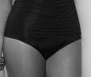

The following illustration is an example of a degree of exposure which is not permitted under this Rule:

The distance between HL and PL on the side must be more than 5 cm

STATUS: 2014 WDSF AGM, BUCHAREST, ROMANIA, JUNE 15, 2014

Man’s Top Opening Point (TOP) – point, to which top or shirt can be opened

- centre of the belt buckle or centre of the trousers top line

Colours

- black only ( Bo )

- black (B) – means black and midnight blue

- white (W)

- skin colour (S) the same colour as the dancer’s skin during the competition (with tan)

- skin colour with decoration (SwD)

- any colour (C) – any colour including mixed colours

- any colour except skin colour (CnS)

- one colour except skin colour (C1nS)

Long Sleeves/ed (LS) – length to the wrist, rolled up sleeves is NA

Make-up – includes face make-up, artificial tan, artificial nails, and artificial eye lashes.

Decoration jewellery – jewellery designed to be a part of a dance dress

STATUS: 2014 WDSF AGM, BUCHAREST, ROMANIA, JUNE 15, 2014

1. DANCE DRESS – Only Allowed

Partner |  | Male |  |  |  | Female
Disc. |  | ST |  | LA | ST |  |  | LA
 |  | W LS shirt or W/Bo polo neck |  |  | W blouse | simple C1nS |  | C1nS
 |  | Bo trousers/satin side stripe allowed |  |  | leotard or T | dress + |  | leotard with
 |  | Bo tie/bow tie |  |  | shirt | panties |  | same colour
 |  | Bo socks
 |  |  |  |  | Bo skirt |  |  | skirt
 |  |  |  |  |  |  |  | attached
Juvenile
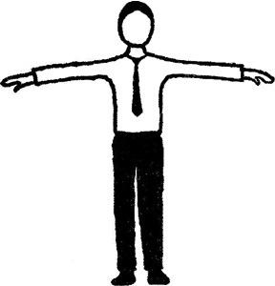
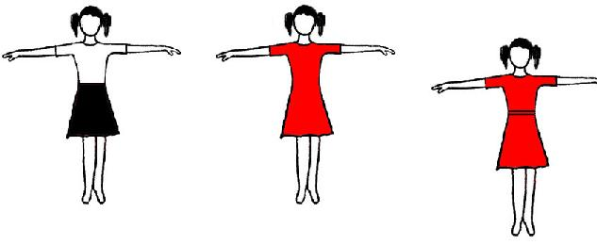

cuts and details – see appendix I |  | cuts and details – see appendix II
W LS shirt or W/Bo LS polo | C shirt/top ( tucked in or | Competition dress | Competition dress
neck top | outside)TOP- | JI –CnS | JI –CnS
Bo vest optional | breastbone | others – C | others – C
Bo trousers | CnS trousers
W bow tie to be worn with wing
collared shirt
B tie to be worn with plain shirt
Bo socks
Junior I
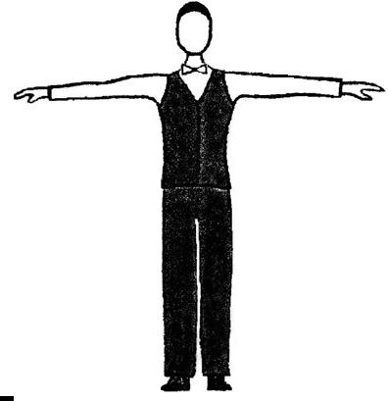
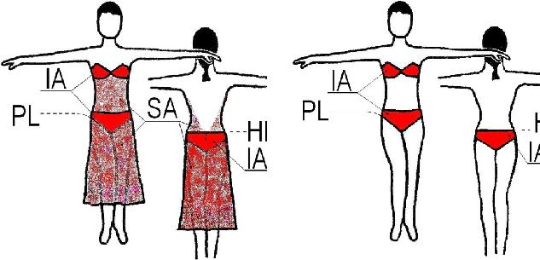

B Jacket suit | B Tail suit | C Shirt/Top
(B trousers | (B trousers | CnS trousers
B jacket | B tails
W shirt | W
B tie | waistcoat
Or W tail | W tail shirt
shirt | W bow tie)
W bow tie)
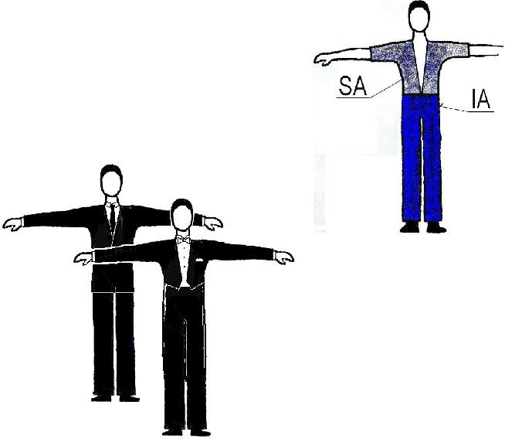
Two piece dresses are allowed, but the top must not be a bikini top only

Junior II | Two piece dresses NA
Youth
Adult
Senior

 | 2. DECORATIONS, LIGHT EFFECTS
 | Partner |  |  | Male |  | Female
 | Disc. | ST |  | LA |  | ST |  | LA
 |  |  |  |  |  | Any decorations – NA
 | Juv |  |  |  |  | Basic materials with light effects - NA
 |  |  | Any decorations – NA
 |  | Basic materials with light effects - NA |  |  |  | Decoration with light effects – NA
 | Jun I |  |  |  |  | (Decoration without light effects is allowed).
 |  |  |  |  |  | Basic materials with light effects – NA
 | Jun II – Sen |  |  |  | NR

3. SHOES, SOCKS, TIGHTS

 | Partner |  | Male |  |  | Female
 | Disc. | ST |  | LA | ST |  | LA
 |  | Heel: may be max 2,5 cm |  |  | Heel: block, may be max 3,5cm
 | Juv |  |  |  | C short socks are allowed
 |  | B socks must be worn
 |  |  |  |  | Tights: skin colour - OA, mesh - NA
 | Jun I |  |  |  | Heel: may be max 5 cm short socks are
 |  |  | Shoes: NR |  | allowed tights: mesh - NA
 | Jun II – Sen |  |  |  |  | NR

4. HAIRSTYLES

 | Partner |  |  |  | Male |  |  | Female
 | Disc. |  |  | ST |  | LA | ST |  | LA
 | Juv |  |  |  |  |  | Decoration and coloured hairspray - NA
 |  |  |  |  |  |  | Decoration with light effects and coloured
 | Jun I |  |  | I If the hair is long it must be worn in a pony |  |  |  | hairspray – NA
 |  |  |  |  | tail |  | (Decoration without light effects are allowed)
 | Jun | IISen |  |  |  |  |  | NR

5. MAKE-UP

 | Partner |  | Male |  |  |  | Female
 | Disc. | ST |  | LA |  | ST |  | LA
 | Juv, Jun I |  |  |  | Make-up - NA
 | Jun II – Sen |  |  |  | NR

6. DECORATION JEWELLERY (not personally jewellery)

 | Partner | Male |  |  | Female
 | Disc. | ST |  | LA | ST |  | LA
 | Juv |  |  | Decoration jewellery - NA
 | Jun I |  |  | Decoration jewellery with light effects – NA
 |  |  | (Decoration jewellery without light effects are allowed)
 | Jun II –
 | Sen |  |  |  | NR

Appendix 1: Juvenile Male Dress

Top

- W plain long sleeved shirt or W/Bo polo neck top -shiny or patterned materials - NA

- shirt wing collar - NA
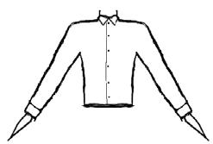
-rolled up sleeves -NA -must be tucked in

Trousers

-shiny or patterned materials - NA -side satin stripe allowed

Appendix 2: Juvenile Female Dress

Combination of different materials in the same colour is allowed. If transparent (see through) materials are used, they must be lined with a non-transparent material in the same colour. Draping and pleating is allowed.

- Necklines – allowed cuts, others - NA:
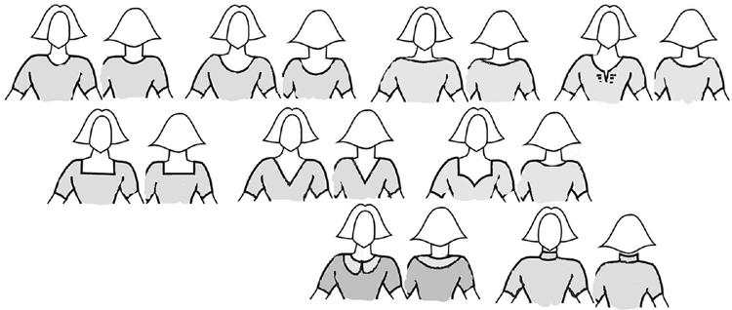

- Sleeves – allowed cuts, others - NA:
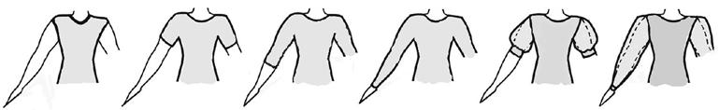

- Skirts:

  - plain or pleated, made of minimum 1 to maximum 3 half circles - OA, one

simple circular underskirt allowed, bigger underskirt - NA.

- frills on the skirt or the underskirt, boning, soft boning or fishing line used in the hem of the skirt – NA

- length must not be more then 10 cm above the knee and not longer than just below the kneecap.

- allowed cuts, others - NA:
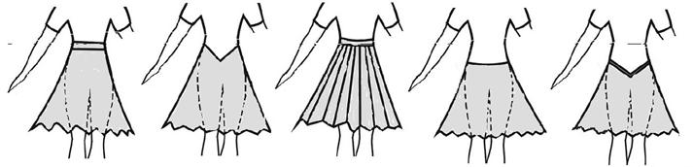

2. new styles that are allowed
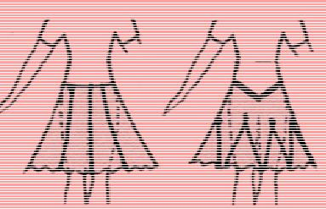

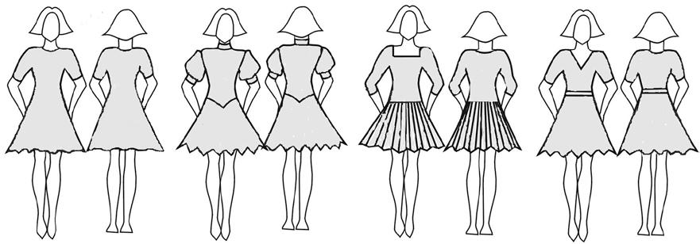
Examples:

